Manual

Manual Testing

IT company Projects – Dev team and Testing team
- Project Technology – (Application – Java – Dev team – Java Language) Testing team
- Project Technology – (Application - .net – dev team - .net language) Testing team
Types of testing
- Manual Testing – Manual 1 and Manual 2
- Web service testing / API testing
- Data Base testing
- Automation Testing
- 2 live project
Project
Manual Testing, Automation Testing, Database testing, API testing.

Manual Testing
Manual 1
Process(SDLC/Fish model, Waterfall model, V-Model, Agile Model)
Testing Types – (Sanity testing, Smoke testing, Functional testing, Regression testing, Retesting etc…)
Manual 2
Real Testing Part

Projects in IT Company – Peoples Involved
Client – Project (Eg. Paytm) – (Requirement/Application)
BA (Business Analyst) – Collects the requirement from Client
Delivery Manager – (DM) – requirement of client are provided on time or not.
Project Manager (PM) – works with BA and Project team
Solution designer/Architect – Application Design or Architecture of Project
Dev Team (Development team) – Developer – Coding
Testing Team – Application Testing

Interview Question

What is your team Size?
Team size – 18 People
Peoples Involved in Project
- BA – 1
- PM – 1
- Solution Designer/Architect – 1
- Developer – 11
- Tester – 4 (including TL)
Ratio of Dev and tester
- Normal Project – VI app, amazon, flipkart
Ratio – 2 dev to 1 tester 2:1

- Banking Domain/Investment/Paytm transaction
3 dev to 1 tester 3:1

Paytm Project
Module 1 Module 2 Module 3 Module 4
Recharge Ticket Booking Gas Booking Bill Payment
3:1 2:1 3:1 3:1

Manual Testing
Manual Testing is the process of manually testing the software to find the defects without using any tool.
Software Testing
Software testing is the process of checking the completeness and correctness of a developed Software.

SQA (Software Quality Assurance)
- It is a process in which client monitors and measures the strength of a developed application.
- Communication between customer and Business analyst is called as software Quality Assurance.

BA
Requirement
Client
Tester
Dev

Factors
- Requirement of client are fulfilled or not.
- Clients expectations (Performance and security)
- Time to deliver
- Cost of project.
- Maintenance

Process- Type
- SDLC ( Software development Lifecycle)/Fish model
- Waterfall Model
- V-Model
- Agile Model

SDLC – (Software development Life Cycle)
- It is a process used by the software industry to design, develop, and test the high quality Software.
- The SDLC aims to produce a high quality software that meets clients expectations, reaches completion within time and cost estimates.
Different types of phases/stages are there
- Information Gathering/Client requirement Gathering
- Analysis
- Design
- Coding/Development
- Testing
- Maintenance/Support
Client (Application)

Information Gathering – BA – BRS (Business requirement specification)

Analysis – BA – SRS (Software/System Requirement Specification) – FRS (Functional Requirement Specification) – CRS – (Customer Requirement Specification)

Design/Architecture – Design – (HLD,LLD)

Coding – Developer – Application Implements

Testing –Tester – Test the application

Maintenance / Support
BRS ( Business Requirement Specification)
- This document generally consists of complete scope of the project , its performance, requirements and Usability.
- BRS is a bridge between Customer/Client and BA.
- BRS document contain the complete requirement of the project.
SRS ( Software Requirement Specification)
- A software requirement Specification is a description of a software system to be developed.
- In SRS document all functional and non-functional requirements are covered.
- A functional requirement defines a system or its components. A non-functional requirements defines the quality of a software system.
- SRS is derived from BRS

SRS document includes
- Functional Flow diagram
Eg . Facebook app – Signup – login page – Home page – Profile page

- Functional Requirement
Eg. Signup page ( Requirement – First name, Last name, Mobile number, Email id, Gender, DOB , Password , Submit button,etc)

- Use cases
Use cases consists of Acceptance and Description Criteria.
Eg. Mobile Number
Description – Mobile number should be in numeric format. It should not accept characters, Special characters, etc.
Acceptance criteria – It should accept only 10 digit contact number. If we are entering Less than or greater than 10 digit it should show an error . “Please enter the right contact number”.

- Screenshot/Snapshot
- Snapshots are visualisation of functionalities before development of product.
- Snapshots is made by BA using HTML code and Irise software.

What is the Difference Between BRS and SRS?
BRS | SRS
Business Requirement Specification | Software Requirement Specification.
This document generally consists of complete scope of the project , its performance, requirements and Usability. | A software requirement Specification is a description of a software system to be developed.
BA people Prepares the BRS | BA people prepares the SRS
From Client BA collects the requirement and Prepares the BRS | SRS is derived from BRS
All requirements are Covered | All Functional and Non-functional Requirements are covered.
Use cases are not present in BRS | Use cases are present in SRS.

Design – Solution designer/Architect
- HLD – (High Level design) – External functionality of gthe application
- LLD – (Low level design) – Internal functionality of the application – (front end developer)
Coding – Developer( Development )
- Coding means program
- One line is code
- Multiple line code is called program
- Set of program written by developer creates the software.
2 types of developer
- Front end developer
UI functionalities /functional flow/ Functional requirement etc developed by front end developer.

- Back end developer
Data management, Data gathering, data security

- Who can work as front end developer and backend developer is called as full stack developer.
Testing – Testers
Testers are working on
- TCD – Test case design – to write test cases
- TCE – Test case execution
Maintenance / Support
We provide some warranty – 1 month free
After 1 month client will pay for support.

Questions
- What is your team size?
- What is SDLC?
- What is BRS and SRS?
- What is SRS and what all it contains?
- What is use cases?

Basic SDLC model/Fish Model

Analysis Design Coding
SRS HLD/LLD WBT Maintenance/
Req Gathering Testing Support
(BRS) BBT
(Review) (Review) (Review)
Verification Validation
Static testing Dynamic testing
Quality Assurance Quality Control
- Fish Model is advance version of SDLC.
- Fish model consists of Verification and Validation.

Difference Between WBT and BBT?
WBT (White Box Testing) | BBT (Black Box Testing)
Developers Perform WBT. | Testers perform the BBT
Types of WBT – Unit testing and integration testing | Types of BBT – Sanity testing, Smoke testing, Functional testing , regression testing etc.
Developers are checking their code of developed application as per the requirement. | Testers are checking the functionality of application as per the requirement.
It is mandatory to have knowledge of programming | No knowledge of programming is required.
WBT is called as code level testing | BBT is called as functional and system testing
+ve scenario Testing | +ve and -ve scenario testing

Difference Between Verification and Validation.
Verification | Validation
In this Testing BA person reviews the BRS and SRS, Designer will review the design, And Developer will check the code. | In this tester will check the functionality of the application
Involved BA, Designer, developer | Involved Tester
Verification is the process of checking that the software meets its specification. | Validation is the process of checking whether the specification captures the customers requirement.
It is also called as static testing or Quality Assurance | It is also called as Dynamic testing or Quality control.
+ve scenario | +ve and –ve scenario test
It includes checking of documents, design, codes and program | It includes testing and validating the Actual Product.

Grey Box Testing
- Grey box testing is combination of both White box and Black box testing.
- Tester is involved in this testing.
- To do grey Box testing tester need programming knowledge.
- The role of Grey box tester is whenever S/W is handed over to tester, tester check its functionality and if any fault occurs in the O/p of function then tester does not revert system back to developer , instead of that tester himself solve or make changes in the code, so knowledge of codeing is required. And it is called as Grey box testing.
Advantages of Fish Model
- It is easy to implement.
- Every stage of this model is tested by a separate team to check the correctness and completeness of application, so it provides a high quality software.
- It provides full documentation of the application.
Disadvantages of Fish Model.
- In this model the review and testing starts from the project initiation to the maintenance phase, due to this reason fish model is a Costly methodology for development.
- It is a time consuming process to develop the software.
- It is an expensive so the development failure will cause lot of damage and loss.

Questions
- Difference between WBT and BBT?
- Difference Between Verification and validation?
- Difference between Static testing and Dynamic testing?
- What is Fish model its advantages and disadvantages?

Waterfall Model
Information
Gathering(BRS)
Analysis
(SRS)
Design
(HLD/LLD)
Coding
Testing
(TCD/TCE)
Maintenance
/support

- It is a process to develop a software.
- Waterfall model is called as a sequential model.
- In waterfall model we can move to next phase when previous phase is completed.
- As phases fall from higher level to lower level like a waterfall so it is called as waterfall model.
- Duration of waterfall model is of 3 months.
Note – Completion of coding phase is the entry criterion for testing phase and completion of testing phase is the exit criterion for testing phase.
Advantages
- Simple and easy to understand and use.
- For smaller projects waterfall model works well.
- Phases are processed and Completed one at a time.
Disadvantages
- For bigger and complex project this model is not good.
- Cannot accept new CR.
- If we are getting any changes we cannot go to the back stage.

V-Model
Verification Validation
(Development) (Testing)
Information Gathering Assessment of Dev phase
And Analysis Test plan Preparation

Design and Coding Design Phase test
Program phase test
Test case design

Integration Smoke or sanity testing
(Build installation) System and Functional Testing
UAT Testing
Documentation

Maintenance/ DRE(Defect removal Efficiency)
Support RFC,CR
Post-mortem Testing

- V-stands for verification and validation
- In V-model verification and validation are running parallel
- In V-model development stages are mapped with the testing stages.
- Duration of V-model is of 3 months
- V-model is used in big organisation.

Assessment of dev phase
- Assessment of dev phase means to make strategy for testing.
- In this phase we decide which methodology is going to be used for testing manual or Automation.

Test Plan Preparation
- In test plan preparation PM prepares a test team and TL prepares the Test plan
- In this phase test estimation is created.
- Test estimation means who will work on which module and how much time it will take to complete.

Design phase test/Program Phase test
- In design phase test HLD and LLD will be checked by designer.
- In this phase code is tested.
- This code testing starts from small unit of program.
- In this testing developer is involved as he knows the code. And we can call it as WBT.

Test Case Design
- Testers are involved in this.
- In test case design test cases are written in +ve and -ve scenario.

DRE – Defect removal Efficiency
DRE = A/A+B
A= defect found by tester
B= Defect found by client side – in UAT
A= 8 B= 2
0.8 = good tester

A=4 B=4
0.5 – 0.8 – Avg tester

A=2 B=6
Less than 0.5 = below avg

Postmortem Testing
- Done by White box tester.
- When whole testing is done and product is ready for release and if the product is not producing the desired o/p then white box tester should have to check all modules in detail.
- This testing is called as postmortem testing.

Advantages
- Time saving and Quick.
- Avoids the downward flow of defects.
- Testing activities like planning , test designing happens well before the coding.

Disadvantages
- If there is any change requirement in between then the test document along with the requirements need to be updated.
- The management of the V-model is quite risky and unstable.
- The v-model is very rigid and hard to execute as compared to other modules.

Agile Model/Methodology/Process
- The agile scrum methodology is combination of both incremental and iterative model for managing product development. (incremental – which keeps on increasing, iterative- which keeps on repeating)
- Agile is continuous process for development and testing.
- Duration of agile is 1week, 2 week, 3 week, 4 week – (In my organisation duration of agile is of 2 weeks)
- Agile is value driven process.
- If CR comes then we will check its impact on development , testing and production or its priority in that application.

Agile framework /Sub module
- XP – extreme programming – continuous development
- Scrum – which helps team to work together (to give sprint wise delivery)
- FDD – Future driven development
- Kanban
- Lean
On which Agile methodology you have worked?
I have worked on Scrum Agile methodology.
Sprint – A sprint is a set period of time during which specific work has to be completed and made ready of review. (Duration of 2 weeks is called as sprint)

Agile Architecture
Information Gathering Product backlog[200 req]
(BRS)

Analysis(SRS) Sprint backlog[20req-1 sprint]
[20req- 2 sprint]
[20req- 3 sprint]

Use Cases User story- 1 single requirement
Description criteria Description
Acceptance criteria Acceptance

Design Design

Coding(WBT) Coding

Testing(TCD/TCE) Testing

Maintenance/Support Maintenance/Support

Peoples Involved in Agile
- Client - Stakeholder
- BA – Product owner
- DM – Solution Master
- PM – Scrum Master
- Designer - designer
- Dev team - developer
- Test Team – tester
Stakeholder
- Client or customer is called stakeholder in Agile
- He is the member of top most body of company.
- At any phase of dev, testing and production they can request for change.
Product owner
- Product owner collects the requirement from stakeholder
- He is the member of sprint planning meeting.
Product Backlog
Product backlog contains the total requirement of the whole project. It includes requirement for all modules.
Sprint Backlog
Sprint backlog contains user story.
It is created by owner.

Agile Meetings/Ceremonies
Meetings | Purpose | Involvement of people
Grooming Meeting  (Before start of sprint) | All the doubts about the requirements are cleared here in the grooming meeting. | 30min/1hr – product owner(Chair person), dev team, testing team, Design team , Scrum master(optional).
Sprint planning Meeting (1st day of sprint) | - Decides the user story(1sprint=20req)  - Estimation(time slot to complete the user story)-  1 user story – 24hrs | 1hr – Scrum master(Chair person) , Design team, dev team, testing team, Product owner (Optional)
Daily stand up meeting (Scrum meeting) | - What we have done yesterday?  - What we are going to do today?  - What are the roadblocks or issues you have faced? | 15min/30min – Scrum master(chair person), Dev team, design team, Testing team, Product owner(optional)
Sprint review Meeting (End Day of sprint) | Demo or review of the completed user story is given. | 1hr – product owner(Chair person), testing team, dev team , design team, Scrum master(optional), Stakeholder (Optional)
Sprint Retrospective meeting (End day of sprint or 1st day of next sprint) | In this meeting all the good and bad things were discussed about the Sprint. (Discussion) | 30 min – Scrum master (Chair person), Dev team, testing team, design team, product owner(optional)

Zero Sprint – it generally refers to the first step or pre-preparation step that comes just before the first sprint. It includes all activities such as development of environment, preparing backlog, project skeleton etc.
Advantage
- Sprint wise delivery
- Working software is delivered frequently.
- Change request are accepted immediately.
- Customers , developer and testers constantly interact with each other.
Disadvantage
- Cost of agile methodology is slightly more as compared to other methodology.
- Less documentation
- If requirement are not cleared before the sprint, the sprint can go out of scope.

Agile Terms
- Burn down chart
How much user story remaining w.r.t. time
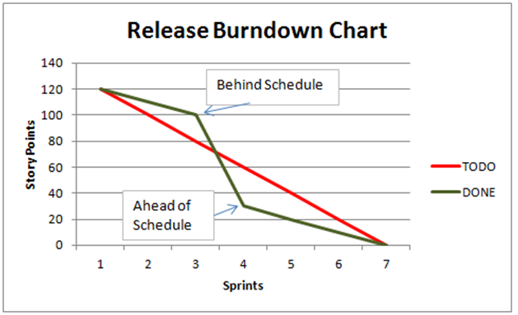

- Burn Up Chart
How much user story completed w.r.t timr
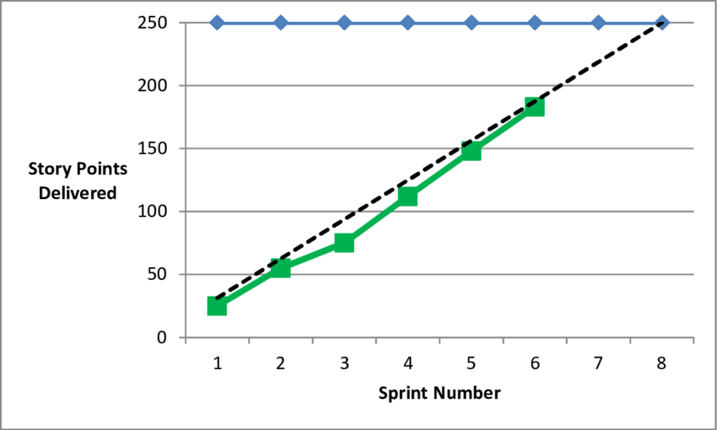

- Epic
It is User Story in sprint
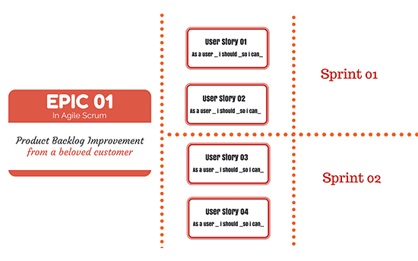
- Velocity
Progress against the estimated work(time)
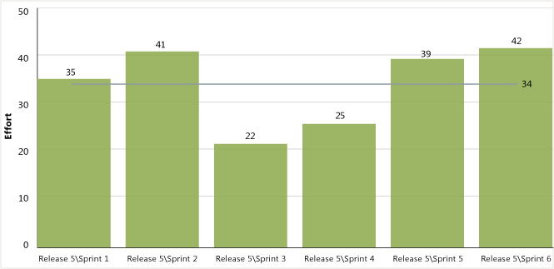

Environments in Project
How many environments are there in your project?

Environment

Prod Environment /live
UAT Environment Dev and Tester
SIT Environment Tester
Dev Environment Developer

Pune company USA Client
Remote Desktop(Access UAT)

Types of testing in different Environment
Dev Environment (WBT)
- Unit testing
- Integration Testing
SIT Environment
Initial Build
- Sanity or Smoke Testing
For stable Build
- System/Functional Testing
- Retesting
- Regression testing etc
Regression Testing
UAT
SIT

UAT Environment
- Alpha Testing
- Beta Testing
Regression Testing
Prod
UAT

Production Environment

Dev Environment

Unit testing
- Testing which will be performed on single module is called as unit testing.
- Unit testing is performed by developer.
- In this application is tested or checked in +ve way.

Integration testing
- In this all the unit modules will be integrated together and testing will be performed on the integrated module.
- Integration testing is performed by developer.
There are three ways of integration Testing
- Top Down approach
- Bottom up approach
- Sandwich/Bidirectional Approach
Top down approach
- In top down approach testing is done by integrating or joining two or more modules by moving from top to bottom.
- In this high level modules are tested first and then low level modules are tested.
- In this type of testing, stubs are used as a temporary module if a module is not ready for integration testing.
- (In this case we are using dummy module.
- Dummy module is created from STUB
- STUB is dummy program created by developer.
Bottom up approach
- If we have sub module but we are not having the main module in that case we are going to use Bottom up approach.
- To perform the testing on Sub module, developer creates the dummy main module.
- Developer will create a main module through a program called driver.
- This driver programs are created in XML language.
Bidirectional/Sandwich Approach
- When Developer want to check the functionality of main module but don’t have sub-module then developer uses STUB program.
- When developer want to check the functionality of sub module but don’t have main module then developer uses Driver Program.
- Combination of Top down and Bottom up is called as Bidirectional approach.

SIT Environment (System integration Testing)

Smoke testing
- It is a software testing process that determines whether the developed software build is stable or not.
- When developer sends a new build/initial build to the tester then smoke testing is performed.
- It is also called as zero level testing or Build acceptance testing.
- In smoke testing we are checking either the build is stable for testing or not.
- Test cases are not written for smoke testing.
- Smoke testing is performed by Developer or tester.
Smoke testing Checkpoints/validation
- Validating the core functionality
- Validating GUI/UI functionality
- Validating the links present in the build
- Validating the tabs
- Validating the pages.
In this testing we are going to verify all the basic functionalities are working or not based on this we will accept or reject the build.
According to test lead he will send a mail to development lead , saying that we are accepting the build for further major testing.
If build is not meeting the acceptance criteria then test lead will email to development lead saying that we are rejecting the build and will be specifying what all are the features not working.

Sanity Testing
- Sanity testing is subset of regression Testing
- After receiving the build from developer sanity testing is performed to ensure that the code changes or new added particular module is working as expected.
- If it is working as expected then we will be performing further functional testing.
- If the defects are found during sanity testing , then build is rejected that is helpful in saving time for regression testing.
- Sanity testing is performed by tester.

Difference Between Smoke and Sanity testing?
Smoke Testing | Sanity Testing
It is a broad approach to testing where all parts of the application are tested. | It is a narrow approach of testing where specific parts of the application are tested.
Smoke testing is the first testing performed on the initial build. | Sanity testing is performed when build is comparatively stable.
It is used to test end to end function of the application | It is used to test only modified or defect fixed functions.
Smoke testing is performed by developer or tester. | Sanity testing is performed by tester.
In this we are going to check whether the build is ready for testing or not. | It is a subset of regression testing in this we are going to focus on particular part of our application.

Regression Testing
- When we are moving from one environment to another environment regression testing is performed.
- Also we are going to perform regression testing whenever any new CR comes from the customer.
- After fixing the defects we will checking that other functionality of the application are working as expected or not due to that defect fixing changes. That is nothing but regression testing.

Retesting
- When we find any defect then that defect is raised to developer and developer will fix that defect, then tester is going to check whether that defect is fixed or not that means he will retest it. That is nothing but retesting.

System and Functional Testing
It is nothing but BBT
In this testing we are going to check the complete functionality of the application.
System and Functional Testing includes
- Usability testing
- Functional Testing
- Security testing
- Performance Testing

Usability Testing
Testing the user friendliness of the application is called as usability testing.
Factors that decide the user friendliness of the application.
- It should be easily accessible
- Application should be in easy language
- It should be easy to understand
- Appearance of the application
- Proper help text message should be displayed
- If user is doing any mistake or entering wrong credentials it show error message.
- Navigation should be very simple.

Functional Testing
- Functional testing
- Non-functional Testing

Functional Testing
It depends on validating/checking the internal functionality of the application/module/sub module as per the requirement.
It includes six types of coverage’s/testing
- Behavioural testing/coverage
- Input domain testing/coverage
- Error handling testing/Coverage
- Backend testing/coverage
- Service level testing/coverage
- Calculation based testing/coverage

Behavioural Testing/Coverage
In this we are validating or checking the behaviour of the application.
Validate object and behaviour of object
Object | Behaviour of object
Text box | Focus or unfocus
Radio button | On/off
Listbox / dropdown | Enabled or disabled
Checkbox | Clickable or non clickable

Input Domain Testing/Coverage
Validating or checking the data types and size/length of data which we are passing into the object(Web element)
Eg. Mobile number field-

Datatype – Number or int size/length – 10
In this we have 2 types
- BVA (Boundary value Analysis)
- ECP ( Equivalence class partitioning)
BVA (Boundary Value Analysis)
- In BVA we are going to check the Size/length of data passing into the object.
- In BVA we are going to check how our system is functioning or working when we insert a boundary value.
- Formula of BVA – Min, Max, Min-1 , Min+1, Max-1, Max+1
Eg – Password textbox accepts 4 to 8 char
Object | Passing criteria | Fail criteria
Text box with 4 char | pass
Text box with 8 char | pass
Text box with 3 char |  | Fail
Text box with 5 char | pass
Text box with 7 char | pass
Text box with 9char |  | fail

Equivalence Class Partitioning
- In ECP we are going to define the data types which we are passing into the object.
Eg.
Object | Passing Criteria | Fail criteria
Mobile Number(Textbox) | Int(0-9) | A-Z, a-Z , Special Char
4-8 char surname textbox | A-Z, a-z | Special char,int(0-9)

Error handling coverage / Testing
In this testing we will be validating/ checking the application by passing invalid test data that application is showing error message or not.
Eg. Payment tab – debit card
Debit card no.
Validity
CVV
Holder name

Submit

Debit Card – By passing invalid card number – Error message – Please provide valid debit card number.
By keeping the card number field blank – this field should not be blank/ Please provide debit card number.

Backend Coverage/Testing
In this we will be validating/Checking whatever operations are been performed on front end same are stored in backend/database or not.
Eg. SIP ,EMI

Service level Testing/Coverage
In this we are going to check the sequence and functions of module on the basis of functional flow diagram. We check working of system as per functional flow diagram.

Calculation based testing/ coverage
We check arithmetic operations it includes addition , subtraction , multiplication and division.

Non–Functional testing
Validating/checking the external functionality of the application or how our application is interaction with other application.
Types of Non–Functional Testing
- Recovery testing
- Compatibility testing
- Configuration testing
- Intersystem testing
- Installation testing
- Parallel testing
- Sanitation/garbage testing
- Globalization testing

Recovery Testing
- It is a testing which verifies software ability to recover from failures like software/hardware crashes , network failure, etc
- Process of checking the system is able to recover from abnormal situation to normal situation.
Eg. Restart the system when browser has multiple sessions open and check whether the browser is able to recover it or not. , Download.

Compatibility testing
It is a testing to check whether our application is capable of running on different OS, Network environment , mobile devices, browsers etc.
Types of compatibility testing
- Forward compatibility testing
- Backward compatibility testing
Forward compatibility testing
Build is correct but OS or browsers are not working properly then it is called as forward compatibility testing.
Backward compatibility testing
- I have worked in backward compatibility testing.
- In backward compatibility testing I have worked on browser compatibility testing.
Browser compatibility testing are of two types
- Cross browser compatibility testing
We will be validating our build is working properly on different types of browser or not.
Eg. Chrome , firefox, IE , Edge etc

- Version Comparison Compatibility testing
In this we will be validating the different version of same browser is supporting our build or not.
Eg. Chrome browser with latest version 98.00, 97.45, 96.35

Configuration Testing
- It is the process of validating or checking whether our application is working on different hardware or not.
- It is nothing but hardware compatibility testing.
Eg, OS , Android , ios devices etc.

Inter-System testing
It is the process of checking or validating whether our application shares data with other application or not.
Eg,
Book my show
Paytm

Installation Testing (not performed)
It is been performed to check if the software has been correctly installed or not and product is working as per expectations.

Parallel Testing
Parallel testing is a testing to test the components of the application simultaneously, to reduce the time.

Sanitation Testing
Validating or checking the extra features added by the developer but not present in SRS document.
Eg, Amount mobile -
111111111
+91
Rs
100

Globalisation Testing
It is a process of checking whether our application supports different languages or not.
It includes
- Localisation testing
In this we are going to check whether or application supports local language or not.
Eg. Marathi , hindi

- Internationalisation
In this we are going to check whether or application supports international language or not.
Eg. Spanish , French , German etc

- Globalisation
To check whether our application supports English language or not.

Security testing
Security testing is a process of checking privacy related to user application.
Types
- Authorization
- Access control
- Encryption and decryption
Authorisation
Process of checking whether person is authorised or not. Authorised person is registered or not.
Access Control
Process of checking whether authorised person has permission to access specific operations.
Encryption and Decryption
Encryption is the process of converting normal message (plain text) into meaningless message (Cipher text).Whereas decryption is the process of converting meaningless message into its original form.

Performance Testing
Performance testing is termed as a type of software testing to ensure that software application will perform as expected under the fluctuating workload.
Attributes of performance testing
- Speed – It shows whether the software responses quickly in all conditions.
- Scalability – How much load the software can handle when multiple use performing operations with the software for a particular time period.
- Stability – It helps to know that the software is stable under the fluctuating loads.
- Reliability (Consistent) – It checks whether the software can perform a fault free task for a given period of time.

UAT (User acceptance testing)
- UAT is called as Customer acceptance testing.
- In UAT we check The real time scenarios of the application.
- UAT is a type of testing which is performed by the client or end user to verify or accept the software before moving it to production environment.
- After completion of all the testing in SIT environment we perform UAT testing.
- In UAT both dev and testers are involved.
- UAT is a type of testing which is done by customer before accepting the final product.

Prerequisites of User acceptance testing.
- Business requirements must be available.
- Application should be fully developed.
- Unit testing, integration testing, System and Functional testing etc. should be completed.
- Only cosmetics errors are acceptable before UAT. (cosmetic error – spelling mistakes , tab sequence , background colour of specific field etc)
- Regression testing should be completed with no major defects.
- All the reported defects should be fixed and tested before UAT.
- UAT environment must be ready.
- Mail from testing team should be there that system is ready for UAT testing.
Who performs UAT?
- Client – Alpha Testing
- End user – Beta Testing

What is the difference between alpha testing and beta testing?
Alpha Testing | Beta testing
In alpha testing client is involved | In beta testing End user is involved
In alpha testing both dev and testers are present | In Beta testing dev and testers are not available immediately.
Alpha testing ensures the quality of the product before forwarding it further. | Beta testing also concentrates on the quality of the product but collects the users input on the product and ensures that the product is ready for real time users.
Alpha testing requires a testing environment | Beta testing doesn’t requires a testing environment.
Alpha testing may require a long execution Cycle. | Beta testing requires only few weeks of execution.
In alpha testing critical issues can be immediately identified and fixed. | Feedback from the end user are collected and that are implemented in the further version of application.

Production issue
- If we found a issue/defect in production it is called as production issue.
- If we have missed some functionality while doing testing production issue may occur which is called as Hot-Fix.

What should we do Ife we found a defect in production environment?
- Reproduce the defect – Checking in all the environments or checking if we are using the same software and hardware that a client or end user is using.
- Try to receive as much information as possible.
- Find the cause.
- Indicate the time when the bug should be fixed.
- Check if the bug has been fixed.
- You should analyze why the issue has happened.

Testing Terminologies

Monkey Testing
- Monkey testing is a testing to test the application with random i/p to check whether our application is crashing or not.
- It is called as speed testing.
- When there are maximum number of test cases and less time to deliver a product then we do monkey testing.
- In monkey testing we are conducting testing on high priority test cases and core functionality of the application.
Eg. In my project – payment tab – UPI module added- user story – 100 test cases and for execution 2hrs.
PM will say execute the test cases in 2hrs – Tester will say I will be performing the monkey testing.

Exploratory Testing
- When we are not having knowledge about the application but we have the test data at that time we are going to perform the exploratory testing.
- Step by step we will be passing multiple test data on the application to get ware about its functionality.
- In exploratory testing we write test cases when we are aware about the application.

Ad-hoc testing
- We have knowledge about the application, we have test cases but not the test data at that time we will be performing ad-hoc testing.
- As per our previous experience about the module or functionality of the application Ad-hoc testing will be performed.

Priority and Severity

Severity
- It is a seriousness of a problem.
- The impact of the bug on the application is known as severity.
Severity can be Critical, Major and Minor.
Critical – It is critical that means the main functionality is not working, and the test engineer cannot continue testing.
Major – It is major , which means that the supporting components and modules are not working fine, but test engineer can continue the testing.
Eg. In CC section we cannot add multiple email id.
Minor – If the severity of bug is minor , which means that all the UI related issues are not working fine, but testing can be processed without any interruption .
Eg. UI problems.

Priority
- Urgency to fix the defect.
- The impact of the bug on the client is known as Priority.
- Priority is important for fixing the bug or which bug to be fixed first or how soon the bug should be fixed.
It can Be High , Medium and Low
High – It is a major impact on the client application and has to be fixed first.
Eg. Payment tab
Medium – In the problem Should be fixed before the release of the current version.
Eg. Search tab
Low – The bug should be fixed if there is time, or we can differed it to the next release also.
Eg. Alignment of misplaced object

Who decides the severity and priority of a defect?
The organisation decides the standards regarding who sets the priority and severity of a defect. However in most cases the severity type of defect is set by the tester based on the product functionality and the written test cases. The priority is decided by the Product owner based on customer requirement.
Examples
- High Priority and High Severity
Eg. Login button not working , payment tab is not working.

- High Priority and low severity
Eg. Bank logo is not correctly present

- Low priority and High severity
Eg. Print button

- Low priority and Low severity
Eg. Terms and policy page not working

Difference Between Error, Defect and Bug?
Error – If there is something wrong in the code then it is called as error.
Defect – While doing the testing when we found the error (Functionality is not working) then it is called as defect.
Bug – When developer will accept the defect then it is called as bug.
The END

